Butterfly Tracking System (BTS)

Use Case Specification Document

UC-1
Retrieve Butterfly Reports
Version No. 1.4

Project Document Revision History
VersionNumber | Date | Revision Author | Description of Revision
1.0 | 11/08/2015 | NIXY team | Initial Creation
1.1 | 11/10/2015 | NIXY team | First Revision (Added Swimlane Diagrams)
1.2 | 11/12/2015 | NIXY team | Modify Swimlane Diagram and alternative flow
1.3 | 11/14/2015 | NIXY team | Modify Swimlane Diagram and Main flow
1.4 | 1121/2015 | Issam Jassim | Modified Main and Alternate flows, added new Swimlane Diagrams

Table of Contents
1. Introduction 4
2. Use Case Information 4
2.1 Actors 4
2.2 Use Case Interaction 4
3. Trigger 5
4. Pre-condition(s) 5
5. Post-condition(s) 5
6. Use Case Swimlane (Activity) Diagram 5
6.1 Display Tracking Information or Download Batch file 6
The following Swimlane diagram covers both Displaying and Downloading of tracking information processed according the exact same criteria (Butterfly Tag ID, Tagger/Sighter ID, Location, Longitude, Latitude, etc) entered by the user. 6
6.2 Custom Region Sightings 7
6.3 Butterfly Migration Route 8
7. Main/Basic Flow(s) of Events (Happy Path) 8
7.1 Retrieve Butterfly Tracking Report: 9
7.2 Custom Region Sightings 9
7.3 Butterfly Migration Route 9
8. Alternate/Exception Flow of Events 10
8.1 Invalid Data Entry 10
8.2 No information matching the criteria 10
9. Assumptions/Business Rules including Non-Functional Requirements 11
10. Use Case Specification Review and Signoff 11

Introduction
The purpose of this use case is to let the user retrieve information or view various reports/diagrams about butterfly tagging/sightings using different criteria from the system. The functionalities are categorized into either functional or non-functional requirement. The functional ones listed are as follows:
- Retrieve Butterfly Tracking Report: Display or allow the user to download various reports by different criteria (by tag number, tagger, reporter, location, or date)
- Custom Region Sightings: Given a coordinate and a radius (in miles) by the user, give a visual of all butterfly sightings in the region
- Butterfly Migration Route: Given a butterfly tag number by the user, display all the information about the butterfly, including the list of migration route in the format of visual table.

The system will use the same criteria to for displaying and batch file processing of butterfly reports. This criterion will include one or more of the following: Butterfly Tag ID, Date, Butterfly Sighter/Tagger, Location, State, Country, Latitude, and Longitude.

The Butterfly Tracking System is a web-based project. The user interface is to be function properly on all platforms, including desktop computers, notebooks, and mobile devices.

Use Case Information

Actors
The Butterfly Tracking System will allow all users to view or download various butterfly tracking reports. All actors in the following table will be able to make full use of all functionalities in this use case:
Actor Name | Role | Description
Guest | Main | Any user who visit the website
Registered User | Main | Any user with an active account
Administrator | Main | Registered Users with Administrator status

Use Case Interaction
This use case is independent from other use cases without any predecessor or successor.

Trigger
Functionality | Trigger
Retrieve Butterfly Tracking Report | Submit button pressed by the user after inputting the criteria (e.g. tagger, reporter, location, date, and/or coordinates).
Custom Region Sightings | Submit button pressed by user after inputting latitude, longitude and radius.
Show butterfly route | It requires the user to input a certain tag number into the system, and the system returns the other information in the format of form shown on the same page.

Pre-condition(s)
None

Post-condition(s)
The system will show a new window that will either contain a table, a visual map, or a file for the user to download. The following list contains all possible post conditions by each different functionality:
    - Retrieve Butterfly Tracking Report: Display a table or transfer a file to the user containing all the tracking data matching the criteria of the original input.
    - Custom Region Sightings: Display a visual map showing all butterflies sighted in the selected region.
    - Butterfly Migration Route: Display a table showing all the locations where the user selected butterfly was sighted.

Use Case Swimlane (Activity) Diagram
The “User” throughout this section refers to Guests, Registered Users and Administrators, since they will all be able to retrieve various reports using the BTS.

Display Tracking Information or Download Batch file

The following Swimlane diagram covers both Displaying and Downloading of tracking information processed according the exact same criteria (Butterfly Tag ID, Tagger/Sighter ID, Location, Longitude, Latitude, etc) entered by the user.
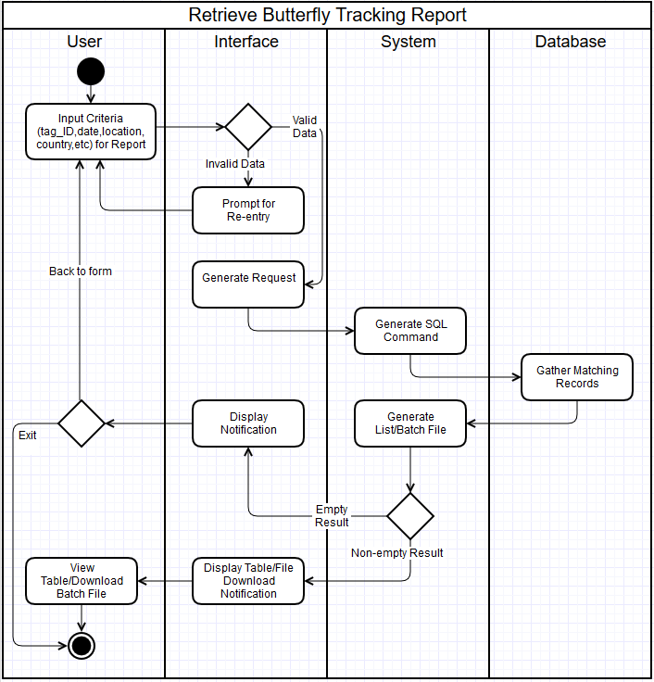
Diagram 6.1 Version 1.3 11/21/2015

Custom Region Sightings
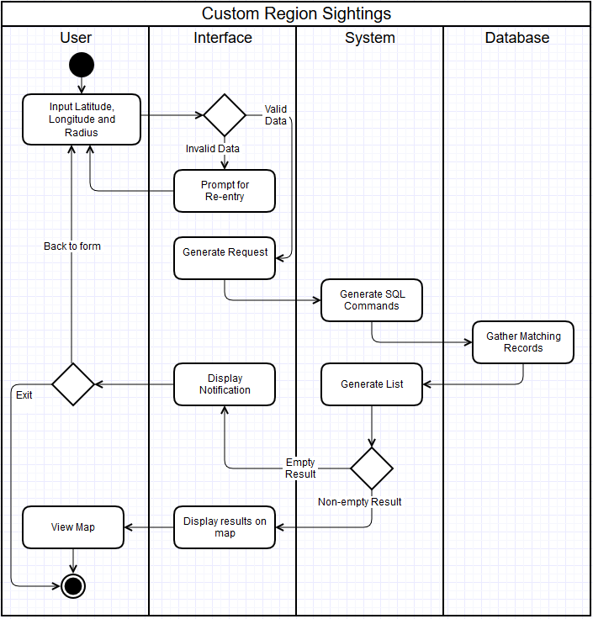
Diagram 6.2 Version 1.0 11/21/2015

Butterfly Migration Route
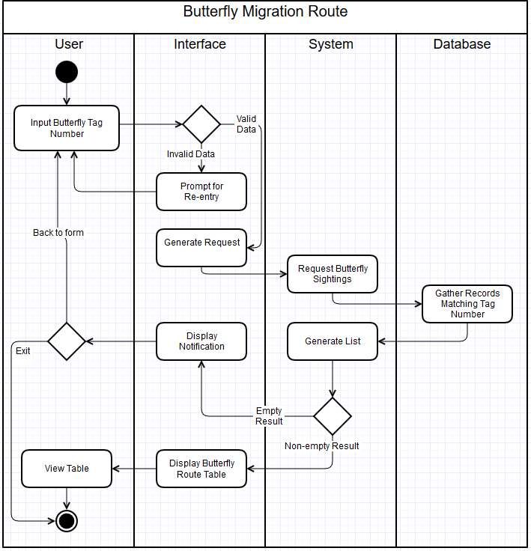
Diagram 6.3 Version 1.0 11/21/2015

Main/Basic Flow(s) of Events (Happy Path)
The “User” throughout this section refers to Guests, Registered Users and Administrators, since they will all be able to retrieve various reports using the BTS.

Retrieve Butterfly Tracking Report:
See Swimlane Diagram 6.1 for a visual representation of this flow.
      - The user will input criteria (tag number, date, sighter/tagger number, location, state, latitude, and/or longitude) for desired report and click submit button.
      - The interface will check for valid data.
      - The interface will generate request and sent to system.
      - The system will generate SQL command and send to database.
      - The database will gather records matching criteria and send to system.
      - The system will generate list/batch file and send to interface.
      - The interface will display table from using list or display file download notification to user.
      - The user will view the table or download the batch file.

Custom Region Sightings
See Swimlane Diagram 6.2 for a visual representation of this flow.
      - The user will input Latitude, Longitude, and Radius and click submit.
      - The interface will check for valid data.
      - The interface will generate request and sent to system.
      - The system will generate SQL command and send to database.
      - The database will gather records matching selected region and send the records to system.
      - The system will generate a list using the matching records and send to interface.
      - The interface will display the sightings on a visual map.
      - The user will view map.

Butterfly Migration Route
See Swimlane Diagram 6.3 for a visual representation of this flow.
      - The user will input butterfly id and click submit.
      - The interface will check for valid data.
      - The interface will generate request and sent to system.
      - The system will generate SQL command and send to database.
      - The database will gather all sighting records matching butterfly id and send the records to system.
      - The system will generate a list using the matching records and send to interface.
      - The interface will generate a report using the list and display on the screen.
      - The user will view the report.

Alternate/Exception Flow of Events
Both alternate flows in 8.1 and 8.2 apply to Swimlane Diagrams 6.1, 6.2, and 6.3.

Invalid Data Entry
      - The users will input criteria for the report/batch file.
      - The interface will check data for validity.
      - The interface will prompt for user for reentry due to invalid data.
      - The user will start the process over by reentering the criteria.

No information matching the criteria
      - The user will input criteria for report/batch file and click submit.
      - The interface will check for valid data.
      - The interface will generate request and sent to system.
      - The system will generate SQL command and send to database.
      - The database will gather records matching selected criteria and send to system.
      - The system will notify interface that no records matched the criteria.
      - The interface will display notification for the user.
      - The user will either start the process over by reentering criteria or exit the system.

Assumptions/Business Rules including Non-Functional Requirements
The browsers that are used to access to the system are modern and capable of properly displaying the reports generated by the system.

Use Case Specification Review and Signoff
Review and Signoff of the Use Case Specification
Name | Project Team Role | Signature | Date
Issam Jassim | Team Leader | Ikj | 11/24/2015
Yue Dai | Front-end Developer | Yd | 11/24/2015
Xiuyan Xin | Front-end Developer | xx | 11/24/2015
Nesrin Mohammed | Database Manager | nm | 11/24/2015

